http://www.wsj.com/articles/most-students-dont-know-when-news-is-fake-stanford-study-finds-1479752576

The Wall Street Journal:

Most Students Don’t Know When News Is Fake, Stanford Study Finds

Teens absorb social media news without considering the source; parents can teach research skills and skepticism
Does children's digital fluency allow them to distinguish between fake news and real news online? WSJ's Sue Shellenbarger has the surprising results of a study of nearly 8,000 students (from grammar school through college) that tested their ability to tell news from ads and to discern websites from hate groups and mainstream professional organizations. Photo: Getty
By
Sue Shellenbarger
Preteens and teens may appear dazzlingly fluent, flitting among social-media sites, uploading selfies and texting friends. But they’re often clueless about evaluating the accuracy and trustworthiness of what they find.
Some 82% of middle-schoolers couldn’t distinguish between an ad labeled “sponsored content” and a real news story on a website, according to a Stanford University study of 7,804 students from middle school through college. The study, set for release Tuesday, is the biggest so far on how teens evaluate information they find online. Many students judged the credibility of newsy tweets based on how much detail they contained or whether a large photo was attached, rather than on the source.

Social Media Companies Tackle Fake News
Your browser does
Twitter, Facebook and Google are taking steps to reduce fake news, misinformation, and harassment on the internet after users expressed concerns that false news stories and hate speech fueled divisiveness in the recent presidential election campaign. Photo: Bloomberg News
More than two out of three middle-schoolers couldn’t see any valid reason to mistrust a post written by a bank executive arguing that young adults need more financial-planning help. And nearly four in 10 high-school students believed, based on the headline, that a photo of deformed daisies on a photo-sharing site provided strong evidence of toxic conditions near the Fukushima Daiichi nuclear plant in Japan, even though no source or location was given for the photo.
Facebook Inc. and Alphabet Inc.’s Google are taking steps to prevent sites that disseminate fake news from using their advertising platforms, and Twitter Inc. is moving to curb harassment by users. But that won’t get rid of false or biased information online, which comes from many sources, including deceptive advertising, satirical websites and misleading partisan posts and articles.
A growing number of schools are teaching students to be savvy about choosing and believing various information sources, a skill set educators label “media literacy.” A free Stanford social-studies curriculum that teaches students to judge the trustworthiness of historical sources has been downloaded 3.5 million times, says Sam Wineburg, a professor in Stanford University’s Graduate School of Education and the lead author of the study on teens.
However, fewer schools now have librarians, who traditionally taught research skills. And media literacy has slipped to the margins in many classrooms, to make room for increased instruction in basic reading and math skills.
Devorah Heitner, author of “Screenwise” and founder of Raising Digital Natives, an Evanston, Ill., provider of consulting services to schools, suggests parents pick up on their children’s interests and help them to find and evaluate news on the topic online. Encourage them to read a variety of sources. For small children, Common Sense Media, a San Francisco nonprofit, lists browsers and search sites that are safe for children, including KidzSearch.com and KidsClick.org.

Evaluating the Credibility of News Sources
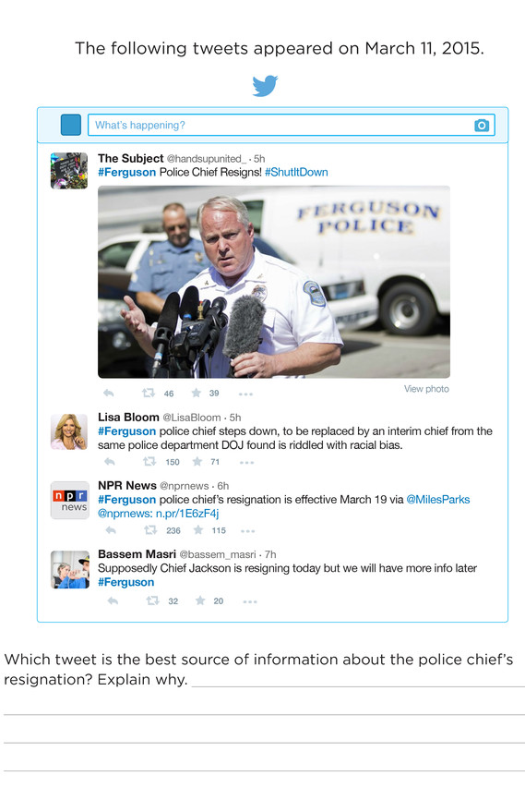
As part of Stanford University’s study of students and online news, it asked middle schoolers which of the four tweets, above, were the most trustworthy. More than half of the 204 students responding trusted Lisa Bloom’s tweet more the one from NPR, noting it had the most information. A sample student response: ‘The best tweet for information is the first one because it actually shows him resigning in a picture, and it gives a caption saying that he is resigning.’ Photo: Stanford History Education Group
Parents can instill early a healthy skepticism about published reports. Vincent Tran and his wife Christina allow their three children, ages 10, 8 and 6, to research sports, games and other topics that interest them by googling or by asking Siri or Alexa. Mr. Tran, a Web architect, blocks sites he considers inappropriate for his children and doesn’t allow them to use social media.
He notices when they have trouble sorting facts from fiction, and “we spend a good deal of time asking them where they get their information,” Mr. Tran says. He and his wife also ask them during family dinners about topics they’ve been exploring, “and hopefully challenge them to think,” he says.
By middle school, preteens are online 7-1/2 hours a day outside of school, research shows. Many students multitask by texting, reading and watching video at once, hampering the concentration needed to question content and think deeply, says Yalda T. Uhls, a research psychologist at the Children’s Digital Media Center at the University of California, Los Angeles.

Evaluating the Credibility of a Source
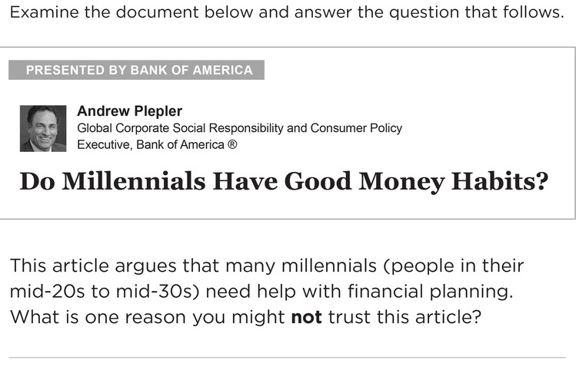
As part of Stanford University’s study of students and online news, it asked middle schoolers to give reasons they might not trust the article by a Bank of America executive on financial planning. Almost 70% of 200 students responding didn't highlight the authorship as a reason for mistrust. A sample response: ‘I wouldn’t trust it because some millennials do have good money habits.’ Photo: Stanford History Education Group
By age 18, 88% of young adults regularly get news from Facebook and other social media, according to a 2015 study of 1,045 adults ages 18 to 34 by the Media Insight Project.
This risks creating an “echo chamber effect,” because social media tends to feed users news items similar to those they’ve read before, says Walter C. Parker, a professor of education at the University of Washington, Seattle. He advises parents to ask children about what they’re reading online, and let them see you reading news from a variety of sources. Try watching several different TV news programs with them, to compare coverage.

More Work & Family Columns
Related columns by Sue Shellenbarger
- Bad Job Interview? Ask for a Do-Over Nov. 15, 2016
- How to Get a Child to Talk About Bullying Nov. 15, 2016
- Am I Too Old to Be Moving Back Home With Mom and Dad? Nov. 8, 2016
- Thanks for Putting Us in Your Will Oct. 25, 2016
- The Perfect ‘Teen Cave’ Oct. 25, 2016
Teens also can learn basic skills used by professional fact-checkers, Dr. Wineburg says. Rather than trusting the “about” section of a website to learn about it, teach them “lateral reading”—leaving the website almost immediately after landing on it and research the organization or author. Also, explain to teens that a top ranking on Google doesn’t mean an article is trustworthy. The rankings are based on several factors, including popularity.
Students should learn to evaluate sources’ reliability based on whether they’re named, independent and well-informed or authoritative, says Jonathan Anzalone, assistant director of the Center for News Literacy at Stony Brook University in New York. Posts should cite multiple sources, and the information should be verifiable elsewhere, he says.

Distinguishing Between Opinion and News
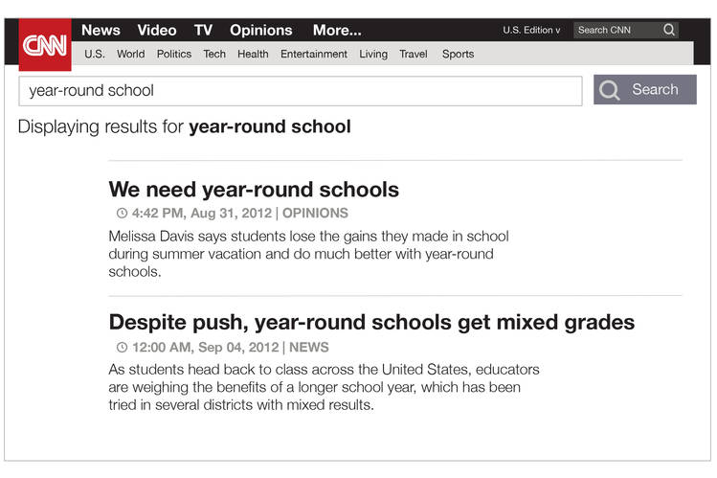
As part of Stanford University’s study of students and online news, it asked middle-school students which of the items above would they read to learn the facts. More than 60% of 200 respondents chose the opinion piece or failed to give clear reasons why they chose the news story. A sample response: ‘I would not survive if we had year-round schools. Kids need a break at some point…’ Photo: Stanford History Education Group
Talk with teens about information they’ve found online and ask, “Why did you click on that?” says Will Colglazier, a history teacher at Aragon High School in San Mateo, Calif., who is helping test Stanford University teaching materials aimed at remedying the problem. ​“Follow their train of thought,” inviting them to explain the steps that led them to the website. If their reasoning reveals faulty assumptions or a lack of skepticism, “use that as a teachable moment,” he says.
Scott Secor has tried to instill in his three children, ages 20, 18 and 16, a habit of noticing the sources of information they read online and learning about their viewpoint or goals. He encourages them to read deeply before forming an opinion. “A rule of thumb at our house is that if an article on a serious topic is less than 100 words,” the length of some fake-news items, more research is needed, says Mr. Secor, of Raleigh, N.C.
He and his wife Laurie also encourage their children to express their views and respect each other’s opinions if they disagree. “The day’s news is a regular conversation topic at the dinner table for us,” Mr. Secor says. Among subjects they discussed during the recent campaign: How much impact would clickbait have on voters’ perceptions?

